# Assignment 2(Queue)

1. Implement Queue & it's function -Enqueue, Dequeue :

CODE :

#include <stdio.h>

#define MAX_SIZE 100

// Global Variables

int queue[100];

int front = -1;

int rear = -1;

int isEmpty()

{

    if (front == -1 && rear == -1)

    {

        return 1;

    }

    return 0;

}

int isFull()

{

    if (rear == MAX_SIZE - 1)

    {

        return 1;

    }

    return 0;

}

void enqueue(int data)

{

    if (isFull())

    {

        printf("Queue is Full!!\n");

        return;

    }

    if (isEmpty())

    {

        front++;

        rear++;

        queue[rear] = data;

        printf("%d is in queue!!\n",data);

        return;

    }

    queue[++rear] = data;

}

int dequeue()

{

    if (isEmpty())

    {

        printf("Queue is Empty!!\n");

        return -1;

    }

    if (front == rear)

    {

        int a = queue[front];

        front = rear = -1;

        return a;

    }

    return queue[front++];

}

int peek()

{

    if (isEmpty())

        return -1;

    return queue[front];

}

void printQ()

{

    if (isEmpty())

    {

        printf("The queue is empty nothing to display!\n");

        return;

    }

    printf("Your Queue is :\n");

    for (int i = front; i <= rear; i++)

    {

        printf("%d\n",queue[i]);

    }

}

void deleteQ()

{

    front = -1;

    rear = -1;

    if (isEmpty())

    {

        printf("Queue deleted successfully!!\n");

    }

}

int main(int argc, char const *argv[])

{

    int ch, data;

    printf("Welcome to simple Queue Program !!\n");

    printf("1 to Enqueue/Push/Insert.\n");

    printf("2 to Dequeue/Pop/Delete.\n");

    printf("3 to Peek.\n");

    printf("4 to Print Queue.\n");

    printf("5 to Delete whole Queue.\n");

    printf("0 to exit Program.\n");

loop:

    printf("\nEnter your choice : ");

    scanf("%d", &ch);

    switch (ch)

    {

    case 1:

        printf("Enter integer to Enqueue/Push/Insert : ");

        scanf("%d", &data);

        enqueue(data);

        goto loop;

    case 2:

        printf("%d Dequeued/Poped/Deleted succesfully!!(if -1 is shown the queue was empty)\n", dequeue());

        goto loop;

    case 3:

        printf("%d Peeked succesfully!!(if -1 is shown the queue was empty)\n", peek());

        goto loop;

    case 4:

        printQ();

        goto loop;

    case 5:

        deleteQ();

        goto loop;

    case 0:

        printf("Exited succesfully!!\n");

        break;

    default:

        printf("Error try again!!\n");

        goto loop;

    }

    return 0;

}

OUTPUT :

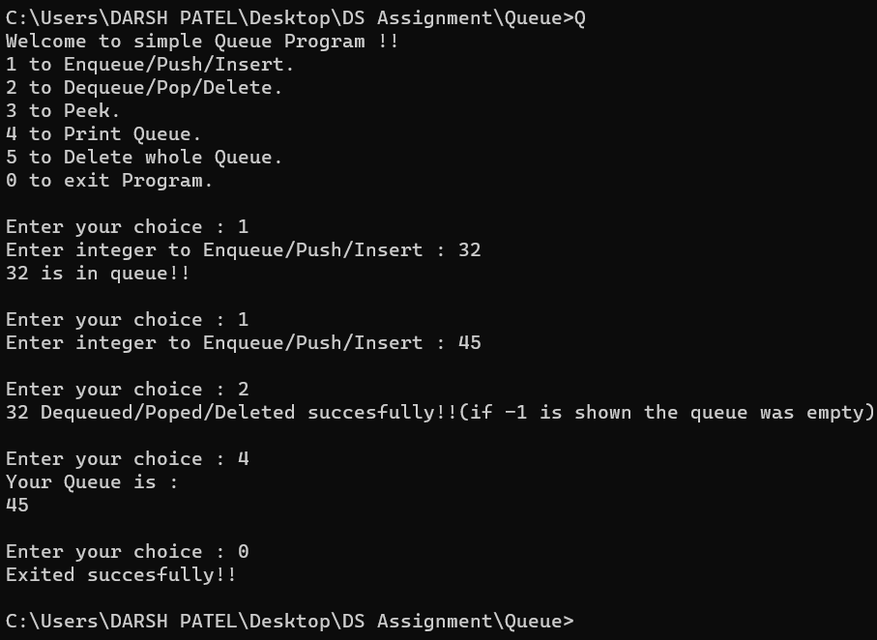

1. Implement Circular Queue :

CODE :

#include <stdio.h>

#define SIZE 5

// Global Variables

int cQueue[SIZE];

int front = -1;

int rear = -1;

int size = 0;

int isEmpty()

{

    return (rear == -1 && front == -1);

}

int inc(int op)

{

    return (op + 1) % SIZE;

}

int isFull()

{

    return (inc(rear) == front );

}

void enqueue(int data)

{

    if (isFull())

    {

        printf("The is Full!!\n");

        return;

    }

    if (isEmpty())

    {

        front = inc(front);

        rear = inc(rear);

        cQueue[rear] = data;

        size++;

        return;

    }

    rear = inc(rear);

    cQueue[rear] = data;

    size++;

}

int dequeue()

{

    if (isEmpty())

    {

        printf("The queue is empty\n");

        return -1;

    }

    if (front == rear)

    {

        int a = cQueue[front];

        front = -1;

        rear = -1;

        size--;

        return a;

    }

    int a = front;

    front = inc(front);

    size--;

    return cQueue[a];

}

int peek()

{

    if (isEmpty())

    {

        printf("The queue is empty\n");

        return -1;

    }

    return cQueue[front];

}

void printQ()

{

    if (isEmpty())

    {

        printf("The queue is empty nothing to diplay!\n");

        return;

    }

    printf("Queue contents: \n");

    while (!isEmpty())

    {

        printf("%d\n",dequeue());

    }

}

void delete()

{

    for (int i = 0; i < SIZE; i++)

    {

        cQueue[i]=0;

    }

    front = -1;

    rear = -1;

    printf("Deleted queue succesfully!\n");

}

int main(int argc, char const *argv[])

{

    int ch, data;

    printf("Welcome to Circular Queue Program !!\n");

    printf("1 to Enqueue/Push/Insert.\n");

    printf("2 to Dequeue/Pop/Delete.\n");

    printf("3 to Peek.\n");

    printf("4 to Print Queue.\n");

    printf("5 to determine size of queue.\n");

    printf("6 to delete whole queue.\n");

    printf("0 to exit Program.\n");

loop:

    printf("\nEnter your choice : ");

    scanf("%d", &ch);

    switch (ch)

    {

    case 1:

        printf("Enter integer to Enqueue/Push/Insert : ");

        scanf("%d", &data);

        enqueue(data);

        goto loop;

    case 2:

        printf("%d Dequeued/Poped/Deleted succesfully!!(if -1 is shown the queue was empty)\n", dequeue());

        goto loop;

    case 3:

        printf("%d Peeked succesfully!!(if -1 is shown the queue was empty)\n", peek());

        goto loop;

    case 4:

        printQ();

        goto loop;

    case 5:

        printf("The size is : %d\n", size);

        goto loop;

    case 6:

        delete();

        goto loop;

    case 0:

        printf("Exited succesfully!!\n");

        break;

    default:

        printf("Error try again!!\n");

        goto loop;

    }

    return 0;

}

OUTPUT :

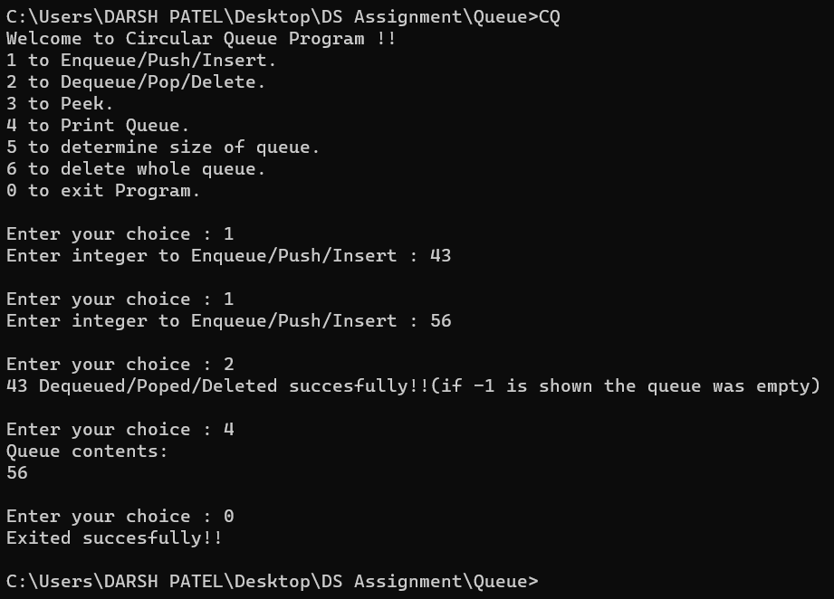

1. Implement Priority Queue :

CODE :

#include <stdio.h>

#define SIZE 10

struct PQ

{

    int data;

    int priority;

} pq[SIZE];

int rear = -1;

int isEmpty()

{

    return (rear == -1);

}

int isFull()

{

    return (rear == SIZE - 1);

}

void enqueue(int data, int priority)

{

    if (isFull())

    {

        printf("Queue is Full!!\n");

        return;

    }

    rear++;

    pq[rear].data = data;

    pq[rear].priority = priority;

    printf("%d is in queue with %d priority!!\n", pq[rear].data, pq[rear].priority);

}

int highestPriority()

{

    int i, p = -1;

    if (!isEmpty())

    {

        for (i = 0; i <= rear; i++)

        {

            if (pq[i].priority >= p)

            {

                p = pq[i].priority;

            }

        }

    }

    return p;

}

int dequeue()

{

    if (isEmpty())

    {

        printf("The queue is empty!!\n");

        return -1;

    }

    int i, j, p, data;

    p = highestPriority();

    for (i = 0; i <= rear; i++)

    {

        if (pq[i].priority == p)

        {

            data = pq[i].data;

            break;

        }

    }

    if (i < rear)

    {

        for (j = i; j <= rear; j++)

        {

            pq[j].data = pq[j + 1].data;

            pq[j].priority = pq[j + 1].priority;

        }

    }

    rear = rear - 1;

    return data;

}

void printQ()

{

    if (isEmpty())

    {

        printf("The queue is empty nothing to display!\n");

        return;

    }

    printf("Your Priority Queue is :\n");

    for (int i = 0; i <= rear; i++)

    {

        printf("Data : %d, Priority : %d\n", pq[i].data, pq[i].priority);

    }

}

int main(int argc, char const *argv[])

{

    int ch, data, priority;

    printf("Welcome to Priority Queue Program !!\n");

    printf("1 to Enqueue/Push/Insert.\n");

    printf("2 to Dequeue/Pop/Delete.\n");

    printf("3 to Print Queue.\n");

    printf("0 to exit Program.\n");

loop:

    printf("\nEnter your choice : ");

    scanf("%d", &ch);

    switch (ch)

    {

    case 1:

        printf("Enter integer to Enqueue/Push/Insert : ");

        scanf("%d", &data);

        printf("Enter the priority of it : ");

        scanf("%d", &priority);

        enqueue(data, priority);

        goto loop;

    case 2:

        printf("%d Dequeued/Poped/Deleted succesfully!!(if -1 is shown the queue was empty)\n", dequeue());

        goto loop;

    case 3:

        printQ();

        goto loop;

    case 0:

        printf("Exited succesfully!!\n");

        break;

    default:

        printf("Error try again!!\n");

        goto loop;

    }

    return 0;

}

OUTPUT :

